Test Description:
<Describe shortly what are you going to test>Free Tv APP
Test Purpose: <Describe shortly what is the purpose of this test>
Test Run Instructions: <Describe any special instructions needed to execute this test>
Test Run Information:  Tester Name: Netanel  Date of Test: 30.11.2023 | Prerequisites for this test: None
Software Versions:
Application: Free TV
Operating System: Xiaomi note 8 pro
Required Configuration: [ browser setup, security, or user ID roles]
No special setup needed
Sanity
STEP | TEST STEP/INPUT | EXPECTED RESULTS | ACTUAL RESULTS | PASS/FAIL
מסך התחברות
Functional
 | Click on -התחברות.  (In the line above) | Return to main page | Return to main page | Pass
Error handling
 | Enter on -קדימה.  without filling in the phone field | An error message will pop up.  "להזין מספר טלפון" | No error messages. | Fail
 | Enter Special Characters  - , . | An error message will pop up.  "מספר טלפון לא תקין" | No error messages. | Fail
 | Enter more number.  9999999999999999999999 | An error message will pop up.  "מספר טלפון לא תקין" | No error messages. | Fail
 | Enter a wrong number phone.  999-9999999 | An error message will pop up.  "אין חשבון מקושר למספר טלפון הזה  צרו חשבון חדש או נסו מספר אחר" | An error message pop up.  "אין חשבון מקושר למספר טלפון הזה  צרו חשבון חדש או נסו מספר אחר" | Pass
 | Try entering a phone number that is missing a number | An error message will pop up.  "מספר טלפון לא תקין" | An error message pop up.  "מספר טלפון לא תקין" | Pass
 | Enter phone number with –  050-1234567 | An error message will pop up.  "אין חשבון מקושר למספר טלפון הזה  צרו חשבון חדש או נסו מספר אחר" | An error message pop up.  "אין חשבון מקושר למספר טלפון הזה  צרו חשבון חדש או נסו מספר אחר" | Pass
 | Enter a word (ע"י העתקה והדבקה) | It is not possible to paste a word | You can enter and no error message appears | Fail
 | Enter number valid. (עם חשבון מקושר)  0501234567 | Takes me right out of the phone field | Takes me right out of the phone field | Pass
 | Enter number valid. (עם חשבון מקושר)  0501234567 | Will send a message with a code.  And we will go to the screen of entering the code | Will send a message with a code.  And we will go to the screen of entering the code | Pass
Password
Error handling
 | Enter incorrect code. "1111" | An error message will pop up.  "קוד שגוי. בבקשה נסו שוב" | An error message pop up.  "קוד שגוי. בבקשה נסו שוב" | Pass
 | Past word or letter | You can't paste a word | You can't paste a word | Pass
 | Click on שלח שוב קוד | Will send a new code | A new code has been sent again | Pass
 | Try entering on שלח שוב קוד Before a minute passed | Can't click | Can't click | Pass
 | Enter a number in the second square at the beginning | The number we entered will only appear in the second square | The number we entered appears in the second square and in the first square as well.  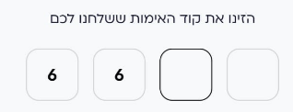 | Fail
 | Enter a number in the third square at the beginning | The number we entered will only appear in the third square | The number we entered appears in the third square and in the first square as well.  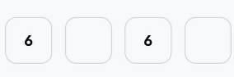 | Fail
 | Enter a number in the fourth square at the beginning | The number we entered will only appear in the fourth square | The number we entered appears in the fourth square and in the first square as well.  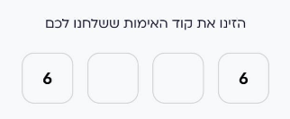 | Fail
Functional
 | Click on חזרה - | We will return to the screen of entering a phone number | We are back to the phone number entry screen | Pass
 | Enter correct code "7060" | We will enter to app | We enter to app | Pass
 | Click on התחברות | We will return to the main screen of -כניסה לשירות | We are back to the main screen of- כניסה לשירות | pass
Gui
 | Wait for more than a minute to be able to click on "שלח שוב קוד" | will be written "שלח שוב קוד" | Write "שלח שוב קוד ב"  (שגיאת כתיב)  | Fail
 | The –"שלח שוב קוד" | Will be written in color that will show pressure | Will be written in color gray  | pass
Profiles
Functional
 | Click on -ניהול פרופילים | We will move to the screen -ניהול פרופילים | We moved to screen -ניהול פרופילים | Pass
 | Click on -הוספת פרופיל | We will move to the screen-הוספת פרופיל | We moved to screen-הוספת פרופיל | Pass
 | Enter name – בדיקה and click המשך | Creates a new profile named "בדיקה" | A new profile called " בדיקה " has been created. | Pass
 | Click on profile -בדיקה | We will go to the screen-עריכת פרופיל | We moved to the screen- עריכת פרופיל | Pass
 | changing the image | the picture will change | The picture changes | Pass
 | changing the name to -test | The name can change | The name changes | Pass
 | Enter name more than 14 characters-  Test12345test1234 | It will be possible to see the whole name in a list of profiles | It is not possible to see the whole name in the profile list 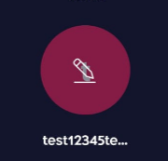 | Fail
 | Check what the maximum letters you can enter | You can enter up to 30 characters | You can enter more than 30 characters.  But after pressing continue all the letters after the 30 are deleted | Pass
 | Rename the profile you're working on  In addition to the name "Test" insert another 30 characters | You can enter more than 30 letters.  But after pressing continue all the letters after the 30 are deleted | The name no changing | Fail
 | Click on -הסרת פרופיל | A message will appear if I'm sure I want to delete the profile | No message appears | Fail
 | Click on -הסרת פרופיל | The profile will be deleted | The profile has been deleted | Pass
 | Delete the profile while you're working on it | There is no option to delete the profile | There is no option to delete the profile | Pass
 | delete a profile that another user is working on | You can delete a profile when other users working on it | You can delete a profile when other users working on it | pass
 | Exit the application and return to it (on the phone the profile worked on) | The app will open on the main profile.  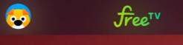 | The app opens on the main profile but there is no picture. 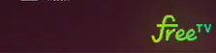 | Fail
 | Try to add movie to favorite.  (from profile you delete) | It will be possible to add to favorites | You can add to favorites | pass
 | Check the maximum number of profiles that can be created | You can create up to 5 profiles | You can create up to 5 profiles | Pass
 | Try to create in 2 device five new profile | You cannot | You cannot | Pass
 | Click on exit from Free TV | A message will pop up asking if we are sure we want to sign out of the account on this device | A message pop up asking if we are sure we want to sign out of the account on this device | Pass
Search bar
Functional
 | Click on – חיפוש | Moved to screen search | Moved to screen search | Pass
 | Search שנות ה-80 | will show me the results of the search | Show me results לשנות ה-80 | Pass
 | Try search word with 2 letters or less | A message will appear requiring at least 3 characters | There is no message that requires at least 3 characters | Fail
 | Try search word with 3 letters or more –"סברי" | will Show my results with word "סברי" | Show my results with word "סברי" | pass
 | Try search in English "red" | Will Show my results with word "red" | Show my results with word "red" | Pass
 | Seach number 100 | Will show me results related to 100 | Will show me results related to 100 | Pass
 | Enter in search word or character without meaning – "xfvsv" | We will receive a message – "לא נמצאו תוצאות מתאימות. " | We will receive a message – "לא נמצאו תוצאות מתאימות " | Pass
 | Leave the search bar empty | The search history will appear | The search history appears | Pass
 | Click on -ניקוי היסטוריית החיפוש | will clear all search history. | Cleared all search history | Pass
Main page
Functional
 | Click on (ן) | A screen will open with a schedule of broadcasts, which were and will be | A screen opens with a schedule of broadcasts, which were and will be | Pass
 | Choose a broadcast that has already passed | You can watch it | You can watch it | Pass
 | Click on what is being broadcast now | You can watch it | You can watch it | Pass
 | Click on what will be broadcast later | A screen with the title of the broadcast will open | A screen with the title of the broadcast open | Pass
 | Try to watch a broadcast that aired two weeks ago | You can watch it | You can watch it | Pass
 | Click on button צפייה | The live broadcast will open | Live broadcast opens | Pass
 | Click on X | Return to the broadcast schedule | Return to the broadcast schedule | Pass
 | Click on הערוץ (12) | A window will open to select another channel | A window open to select another channel | Pass
 | Select 14 | A screen will open with the schedule of past and future broadcasts | A screen open with the schedule of past and future broadcasts | Pass
 | Click on return | Return to main page | Return to main page | Pass
 | Click on button צפייה | The live broadcast will open | The live broadcast opens | Pass
 | rewind the live broadcast | You can | You can | Pass
 | Click on the icon of the live broadcast | We will go straight to the live broadcast | We go straight to the live broadcast | Pass
 | Click on X | We will return to the main screen | We are back to the main screen | Pass
 | Scroll to the side in "ערוצים ישראלים" | It will be possible to scroll to the side to see all the channels to choose from | It is possible to scroll to the side to see all the channels for selection | Pass
 | Scroll down on the main page | It will be possible to scroll down to see all the content offered arranged by category | It is possible to scroll down to see all the offered content arranged by category | Pass
ערוצים
functional
 | Click on ערוצים | We will go to the list of channels available for viewing | We have moved to the list of channels available for viewing | Pass
 | Select in -כאן 11 | We will go to the broadcast schedule of 11 כאן | We moved to the broadcast schedule of כאן 11 | Pass
 | Choose a broadcast that has already passed | You can watch it | You can watch it | Pass
 | Click on what is being broadcast now | You can watch it | You can watch it | Pass
 | Click on what will be broadcast later | A screen with the title of the broadcast will open | A screen with the title of the broadcast open | Pass
 | Click on button צפייה | The live broadcast will open | Live broadcast opens | Pass
 | Click on X | Return to the broadcast schedule | Return to the broadcast schedule | Pass
 | Click on הערוץ (11) | A window will open to select another channel | A window open to select another channel | Pass
 | Select 14 | A screen will open with the schedule of past and future broadcasts | A screen open with the schedule of past and future broadcasts | Pass
 | Click on return | We will return to the channels page | We are back to the channels page | Pass
 | Scroll down in ערוצים | It will be possible to see all the channels available for viewing | You can see all the channels available for viewing | Pass
 | Click on -ראשי | We will return to the main screen | We are back to the main screen | Pass
Secondary menu-עוד
Functional
 | Click on עוד  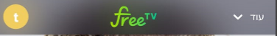 | The Secondary menu open 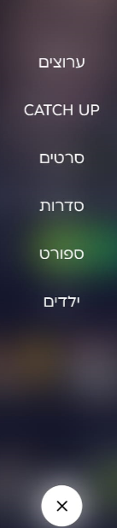 | The Secondary menu open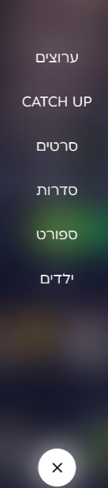 | Pass
 | Click on X | The window will close | The window closes | Pass
 | Click on ערוצים בעוד- | Will open screen with all the channels arranged by categories | open screen with all the channels arranged by categories | Pass
 | Select 11 | The live stream will open | The live broadcast has open | Pass
 | Click on X | We will return to the screen of the channels arranged by categories | We are back to the screen of the channels arranged by categories | Pass
 | Click on return.   | We will return to the main screen | We are back to the main screen | Pass
 | Click on CATCH UP- בעוד | All channels which can be expected a week back or more will appear | All channels which can be expected a week back or more appear | Pass
 | Select 12 | Everything that was broadcast and can be watched again appears | Everything that was broadcast and can be watched again appears | Pass
 | Select in הכוכב הבא-לפני 10 ימים | You can watch it | You can watch it | Pass
 | Click on X | We will return to the screen of CARCH UP | We are back to the screen of CARCH UP | Pass
 | Click on return.   | We will return to the main screen | We are back to the main screen | Pass
 | Select סרטים- בעוד | The screen with the movies order by categories open | The screen with the movies order by categories open | Pass
 | Click on (i) or on the screen  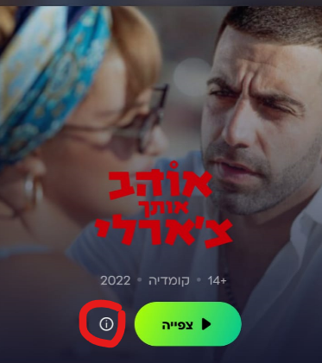 | A window will open with information about the movie | A window will open with information about the movie | Pass
 | Click on (i) or on the screen Several times.  For example 3 | An information window will open only once | The information window opens three times | Fail
 | Click on צפייה.  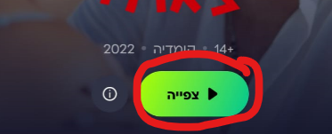 | The movie will start. | The movie starts | pass
 | Click on צפייה Several times.  For example 3 | The movie will start | The movie doesn't start.  And the application tries to start the movie every time and fails.  מצורף סרטון בתיקיה (1 מס') | Fail
 | Select in movies -עולה לראש | We will go to a screen of a summary of the film and a trailer. And the possibility to watch a movie | We go to a screen of a summary of the film and a trailer. And the possibility to watch a movie | Pass
 | Select in movies -עולה לראש  Click on the movies several times (4) | will open only one window of information about the movie (and viewing) | Several windows of information about the film (and viewing) open | Fail
 | Click on + | Add to favorites | Add to favorites | Pass
 | Click on + | Change to V | Change to V | Pass
 | Click on V | removed from favorites | removed from favorites | Pass
 | Click on V | Change to + | Change to + | Pass
 | Click on שיתוף | Will open the possibility to share on several platforms | open the possibility to share on several platforms | Pass
 | Click on שיתוף Several times (5) | Will open the possibility to share on several platforms one time | open the possibility to share on several platforms 5 time | Fail
 | Select in WhatsApp | The link will be sent via WhatsApp | The link was sent on WhatsApp | Pass
 | Check the link that was sent | The link sent is correct and the link opens | The link sent is correct and the link opens | Pass
 | Click on the trailer | The trailer open | The trailer open | Pass
 | Click on צפייה | The movie starts | The movie starts | Pass
 | stop in the middle and exit and then press continue watching | The movie will continue where we left off | The movie starts from the beginning | Fail
 | Click on צפייה Several times.  For example 3 | The movie will start | The movie starts | Pass
 | Select in סדרות - בעוד | The screen with the series order by categories open | The screen with the series order by categories open | Pass
 | Click on (i)  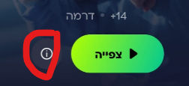 | We will go to the page of information about the presented series | We moved to the page of information about the presented series | Pass
 | Click on (i) or on the screen Several times.  For example 3 | An information window will open only once | The information window opens three times | Fail
 | Click on צפייה.  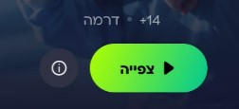 | The movie will start. | The movie starts | pass
 | Click on צפייה Several times.  For example 3 | The movie will start | The movie doesn't start.  And the application tries to start the movie every time and fails. | Fail
 | Select In סברי מרנן(in the screen of the series( | We will go to the information screen about the series | We go to the information screen about the series | pass
 | Click on + | Add to favorites | Add to favorites | Pass
 | Click on + | Change to V | Change to V | Pass
 | Click on V | removed from favorites | removed from favorites | Pass
 | Click on V | Change to + | Change to + | Pass
 | Click on שיתוף | Will open the possibility to share on several platforms | opened the possibility to share on several platforms | Pass
 | Select in WhatsApp | The link will be sent via WhatsApp | The link was sent on WhatsApp | Pass
 | Check the link that was sent | The link sent is correct and the link opens | The link sent is correct and the link opens | Pass
 | Click on טריילרים ועוד | Moved to trailer. | Moved to trailer | Pass
 | Click on טריילרים ועוד | The header color will change from gray to white | The color does not change. | Fail
 | Click on Season 1 | A window will open with the available seasons for selection | A window open with the available seasons for selection | Pass
 | Select season 4 | The episodes will change for season 4 | The episodes change for season 4 | Pass
 | Click on episodes 3 | The episodes start | The episodes start | Pass
 | Click on המשך צפייה | The episode will continue from where we left off | The episode will continue from where we left off | Pass
 | Click on X | We will return to the screen of the series | We are back to the screen of the series | Pass
 | Press X twice | We will return to the screen of the series | We are back to the main screen | Fail
 | Select in ספורט- בעוד | The sports screen will open | The sports screen will open | Pass
 | Select ערוץ ספורט 5 (sport 5) | Live viewing has started | Live viewing has started | Pass
 | Select series – חלון העברות | We will go to the information screen about the series | We go to the information screen about the series | pass
 | Select series – חלון העברות Click on it a few times | The window of the series will open once | The series window opens once | Pass
 | Click on + | Add to favorites | Add to favorites | Pass
 | Click on + | Change to V | Change to V | Pass
 | Click on V | removed from favorites | removed from favorites | Pass
 | Click on V | Change to + | Change to + | Pass
 | Click on שיתוף | Will open the possibility to share on several platforms | Will open the possibility to share on several platforms | Pass
 | Select in WhatsApp | The link will be sent via WhatsApp | The link was sent on WhatsApp | Pass
 | Check the link that was sent | The link sent is correct and the link opens | The link sent is correct and the link opens | Pass
 | Click on שיתוף Several times (5) | Will open the possibility to share on several platforms one time | Will open the possibility to share on several platforms 5 time | Fail
 | Click on טריילרים ועוד | Moved to trailer | Moved to trailer | Pass
 | Click on טריילרים ועוד | The header color will change from gray to white | The header color will change from gray to white | Pass
 | Select episode 2 | The episode starts | The episode starts | Pass
 | Click on X | We will return to the screen of the series | We are back to the screen of the series | Pass
 | Click on X | We will return to the screen of the series | We are back to the screen of the series | Pass
 | Press X twice | We will return to the screen of the series | We are back to the main screen | Fail
 | Click on המשך צפייה | The episode will continue from where we left off | The episode will continue from where we left off | Pass
 | Select ילדים-בעוד | We will move to the screen of series and movies (and channels) for children | We move to the screen of series and movies (and channels) for children | Pass
 | Click on (i)  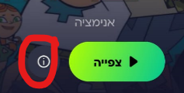 | We will go to the page of information about the presented series | We moved to the page of information about the presented series | Pass
 | Click on (i) or on the screen Several times.  For example 3 | An information window will open only once | The information window opens three times | Fail
 | Click on צפייה.  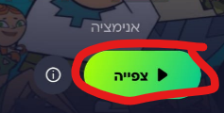 | The movie will start. | The movie starts | pass
 | Click on צפייה Several times.  For example 7 | The movie will start | The movie doesn't start.  And the application tries to start the movie every time and fails. | Fail
 | Select ערוץ הילדים | Live viewing has started | Live viewing has started | pass
 | Select series -פוקימון | We will go to the information screen about the series | We go to the information screen about the series | Pass
 | Click on + | Add to favorites | Add to favorites | Pass
 | Click on + | Change to V | Change to V | Pass
 | Click on V | removed from favorites | removed from favorites | Pass
 | Click on V | Change to + | Change to + | Pass
 | Click on שיתוף | Will open the possibility to share on several platforms | Will open the possibility to share on several platforms | Pass
 | Select in WhatsApp | The link will be sent via WhatsApp | The link was sent on WhatsApp | Pass
 | Check the link that was sent | The link sent is correct and the link opens | The link sent is correct and the link opens | Pass
 | Click on שיתוף Several times (5) | Will open the possibility to share on several platforms one time | Will open the possibility to share on several platforms 5 time | Fail
 | Click on טריילרים ועוד. | Moved to trailer | Moved to trailer | pass
 | Click on טריילרים ועוד | The header color will change from gray to white | The color does not change. | Fail
 | Click on Season 1 | A window will open with the other available seasons to choose from | A window will open with the other available seasons to choose from | Pass
 | Select season 9 | The episodes will change for season 9 | The episodes will change for season 9 | Pass
 | Click on episodes 1 | The episodes start | The episodes start | pass
 | Click on X | Return to screen of episodes. | Return to screen of episodes. | Fail
 | Click on המשך צפייה | The episode will continue from where we left off | The episode will continue from where we left off | Pass
 | Click on צפייה twice | The series will begin | The series does not start (goes into an episode and immediately exits) | Fail
 | Click on צפיה again | The series will begin that the screen is rotated. | The series will begin that the screen is not rotated is rotated.  מצורף סרטון בתיקיה (2 מס') | Fail
הרשימה שלי
Functional
 | Click on הרשימה שלי | Open screen with  מועדפים והמשך צפייה | Open screen with  מועדפים והמשך צפייה | Pass
 | Choose one series that we saved in favorites | We will move to the series page with continued viewing from where we left off | We move to the series page with continued viewing from where we left off | Pass
 | Click on X | Return to הרשימה שלי | Return to הרשימה שלי | Pass
 | slide the series aside | A delete option will appear | A delete option appears.  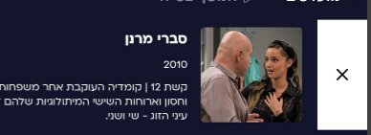 | Pass
 | Click on X | The series will remove from favorites | The series removed from favorites | Pass
 | Click on המשך צפייה | moved to continue watching | moved to continue watching | Pass
 | Select in episodes | We will move to the series page with continued viewing from where we left off | We move to the series page with continued viewing from where we left off | Pass
 | Click on X | Return to הרשימה שלי | Return to הרשימה שלי | Pass
 | slide the series aside | A delete option will appear | A delete option will appear. | Pass
 | Click on X | The series will remove from המשך צפייה | The series removed from המשך צפייה | Pass
 | Click on ראשי | We will return to the main screen | We are back to the main screen | Pass

